# 27th April

Start working on project. Started setting up variables and constants. This involved looking over the template code and adding definitions for distance where appropriate.

I have also been researching quaternions. These appear frequently in game engines and I am curious about their feasibility in this project.  
<https://www.youtube.com/watch?v=zjMuIxRvygQ>

Ok this video has given me a migraine I will just use an array to store position information.

# 29th April

While messing around in my test planets project I have discovered that by not pushing the matrix, the translation begins to compound. This is useful for putting complex models together from basic shapes as the origin moves with each call to the translate function.

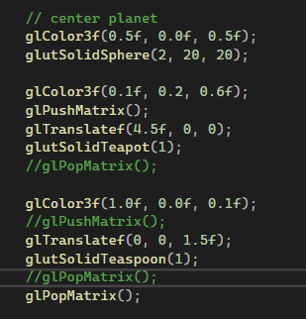

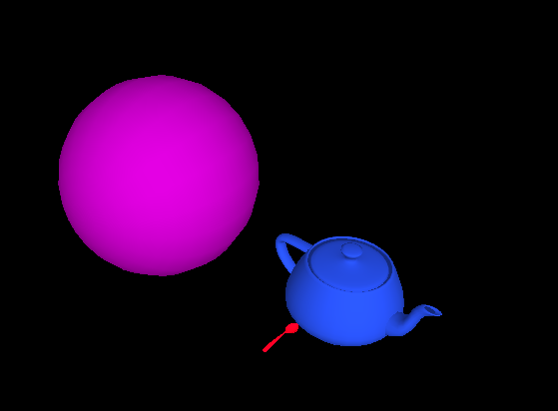

# 5th May

It’s time to get something done. New camera structure with lockon features. This allows me to move the camera around the scene without always having it locked to a certain object at a fixed distance.   
Observe the camera structure below.

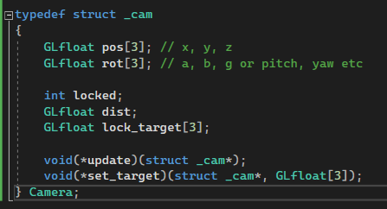In the update function, depending on whether the camera is locked, a different update is called.

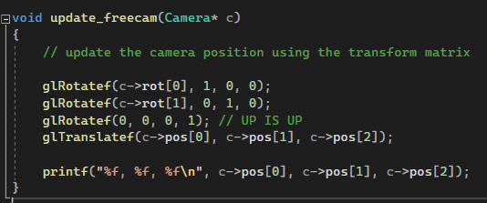However, movement is still janky because the keys move the camera in relation to the world, not the direction that the camera is moving.

So I have devised a method to get the forward vector

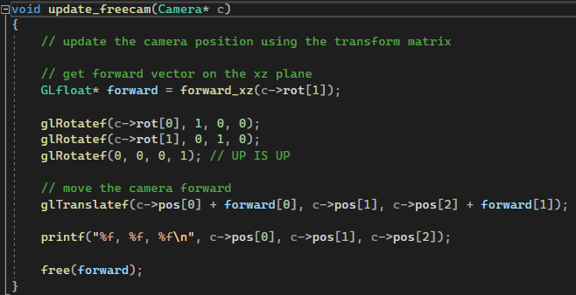  
Which doesn’t work.

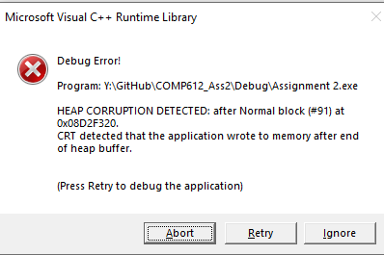

So, at this point I’ve given up making the free camera and have decided to implement the helicopter. For now, it’s just an off-white cylinder. I can’t for the life of me get the fucking thing to work like what the hell is wrong it’s just trig fucking work

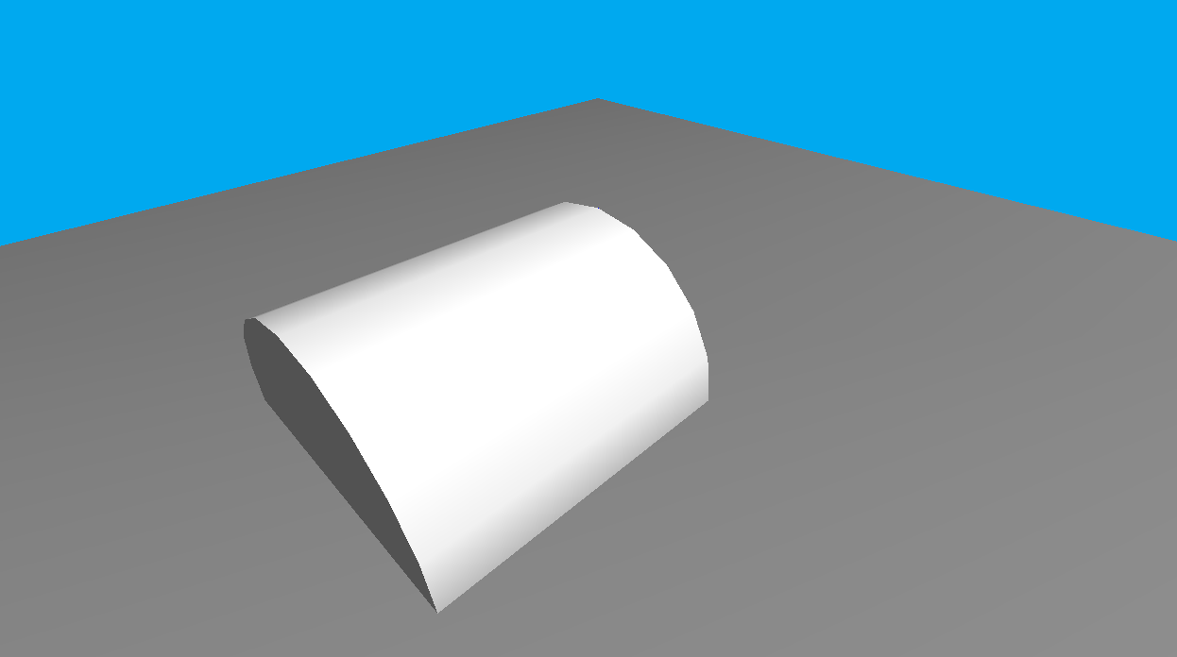  
So the solution was to actually add not subtract the movement vectors. This is because funny things happen when negatives are subtracted from each other. Using trial and error I have completed the movement of the teapot. That’s enough headache for today.

# 8th May

Finished helicopter model. It now looks like a helicopter constructed out of afternoon tea objects.

# 13th May

Implemented simple sound system.

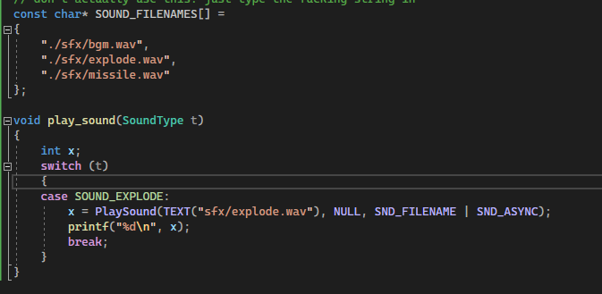

The current camera movement is a bit dodgy. It only moves up and down once per keypress. My solution is to implement a camera controller along with the keyboard controller, using the same logic.

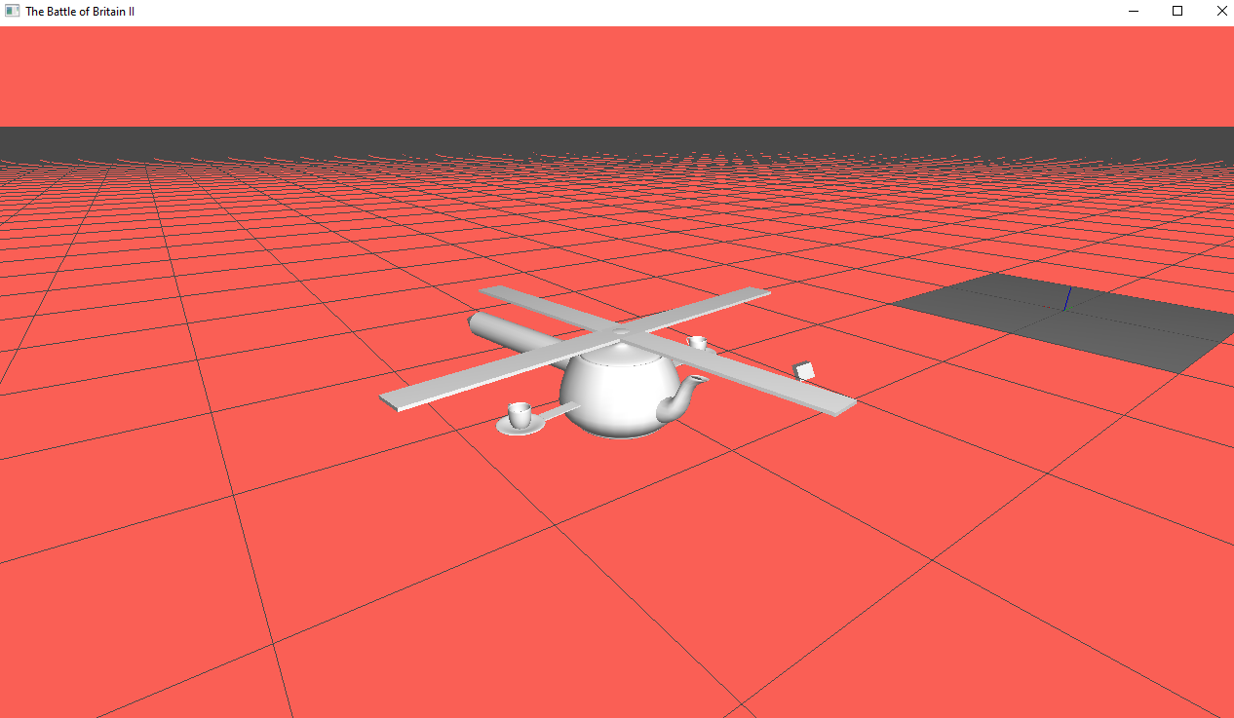

Camera zoom and tilt functions now move smoothly, instead of a fixed distance per keypress.

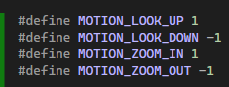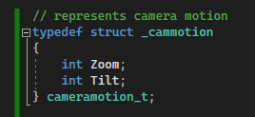

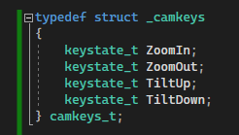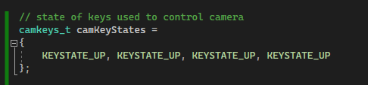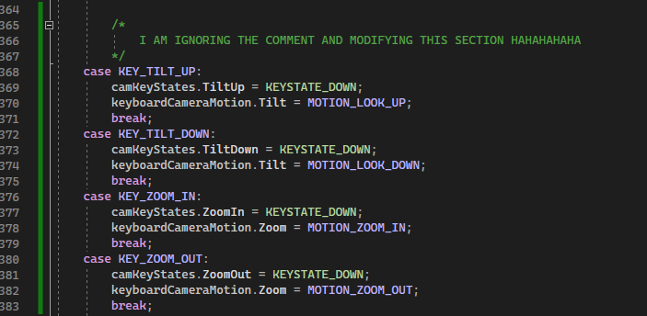

Etc..

# 14th may

Got started on textures. This first attempt didn’t go as planned.

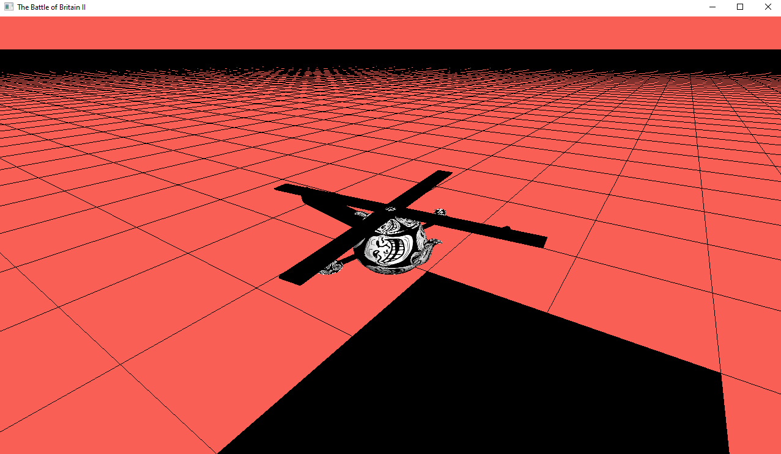

After a bit of faffing about with texture functions, I created this masterpiece.

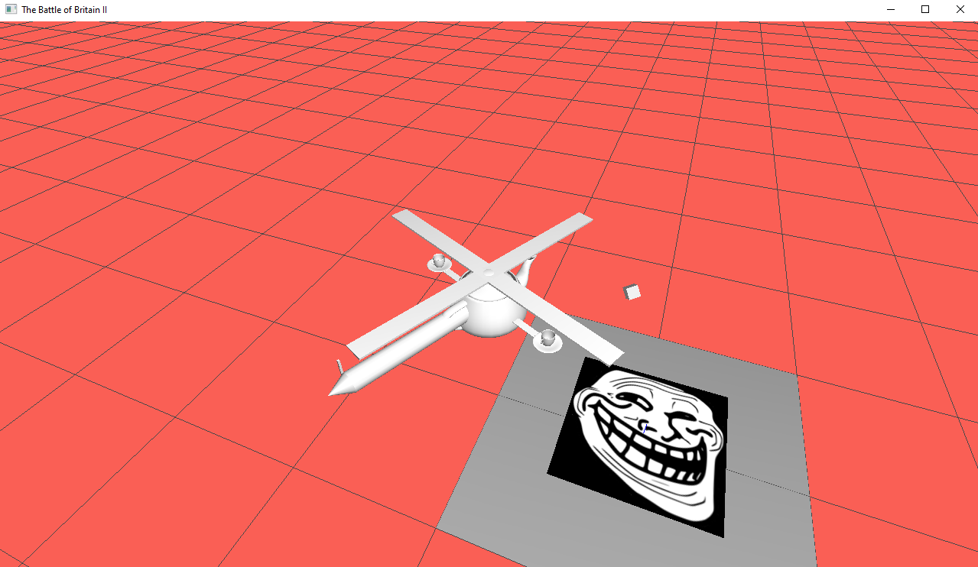

And here’s some code to prove I know what I’m doing

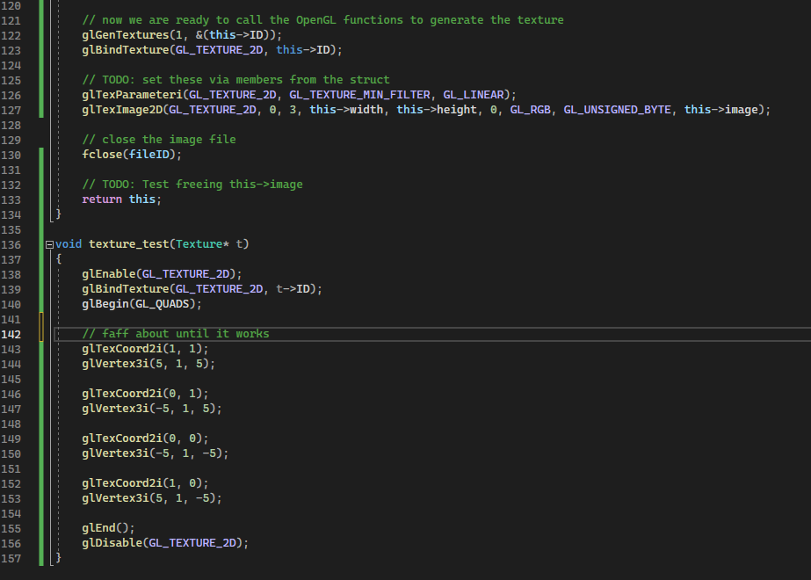

# 21st May

Ground is now a grid of quads inside a display list. Lighting also working. Ground is causing significant issues on lower end hardware. However, even on university computers which are running NVIDIA RTX2060 SUPERs are struggling. My home pc, which is sporting an RTX 3060 is having no trouble at all.

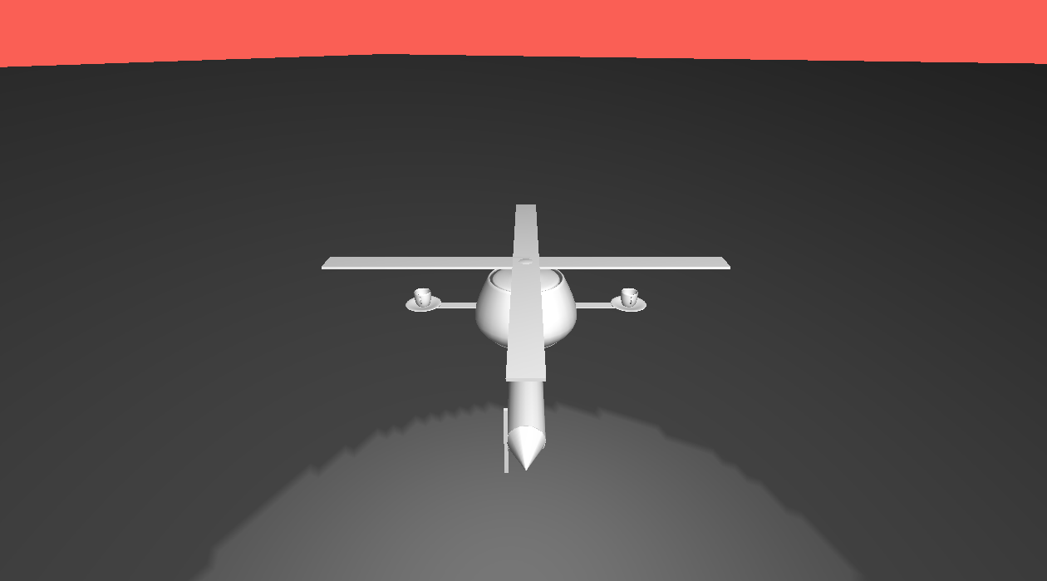

## Performance table

|  |  |  |
| --- | --- | --- |
| **Name** | **Specs** | **Comment** |
| Saggy | Ryzen 7 3800x, RTX 3060 | Yeah, it runs |
| Alessandra | Intel i5-10210U, Intel UHD Graphics | It is running like shit |
| Aidan | Ryzen 7 7600x, RTX 3060 | It runs?? |
| Aidan | Intel i7 10th gen, RTX 2060 SUPER | Runs, but not very well |
| Aidan | Intel i5 (U), Intel UHD Graphics | Seconds per frame. |

# 29th May

Disabled colour materials. Instead, I use this funny function that sets the default materials on all objects currently in the scene.

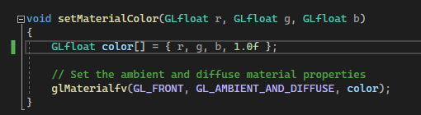

Objects from now on will use their own materials.

I have created a renderlist which is just an arraylist. However, it seems to be causing some problems. Read: Access violation errors. This comes from the fact that it’s still trying to render objects that have expired.

Using the planets project, I can quickly preview material settings since I can’t seem to find the browser version.

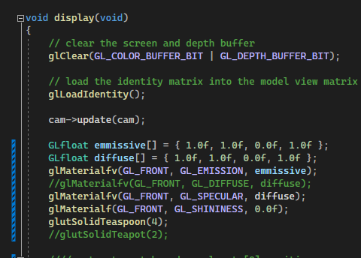

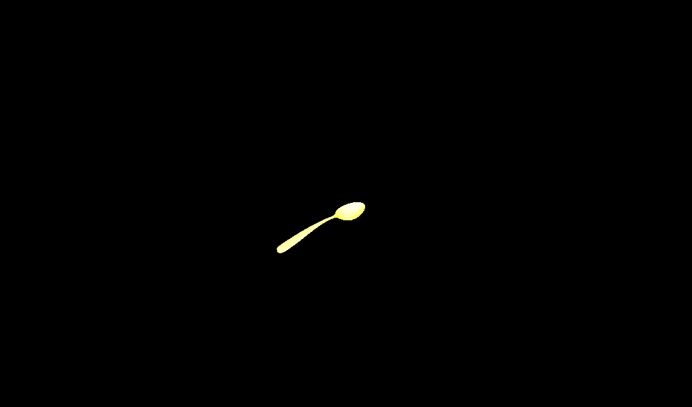

This is useful for creating the correct missile material.

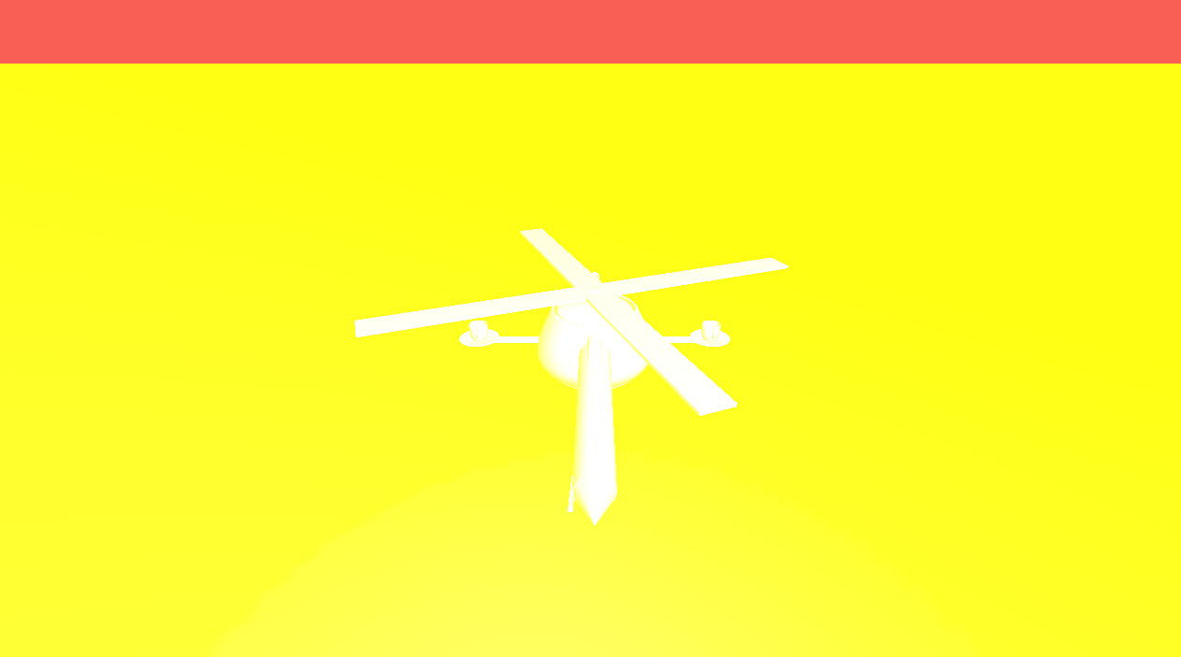

💀

# 30th May

Spent one hour fixing texture loading. Apparently changing my texture registry selection outside of the Texture.c file causes it to break. This duct tape solution seems to work though.



OpenGL state machine abuse.

# 31st May

Added mipmapping. Noticeable difference in image quality:

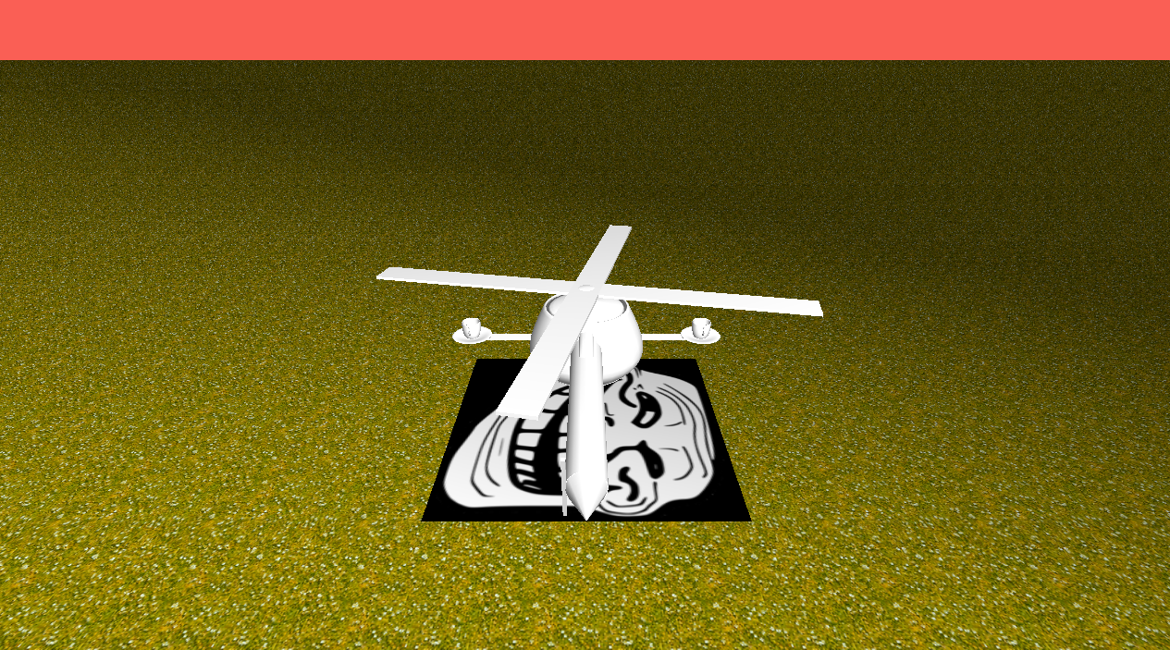

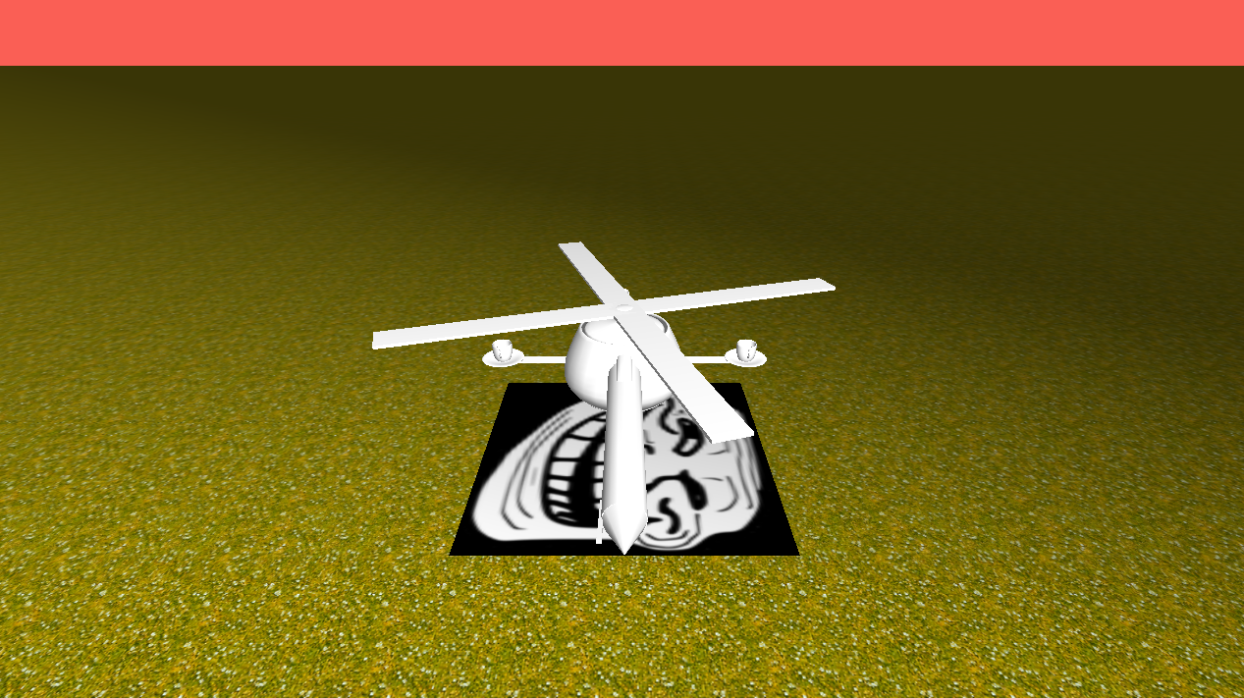

Also enabled fog, but it looks like a sandstorm.

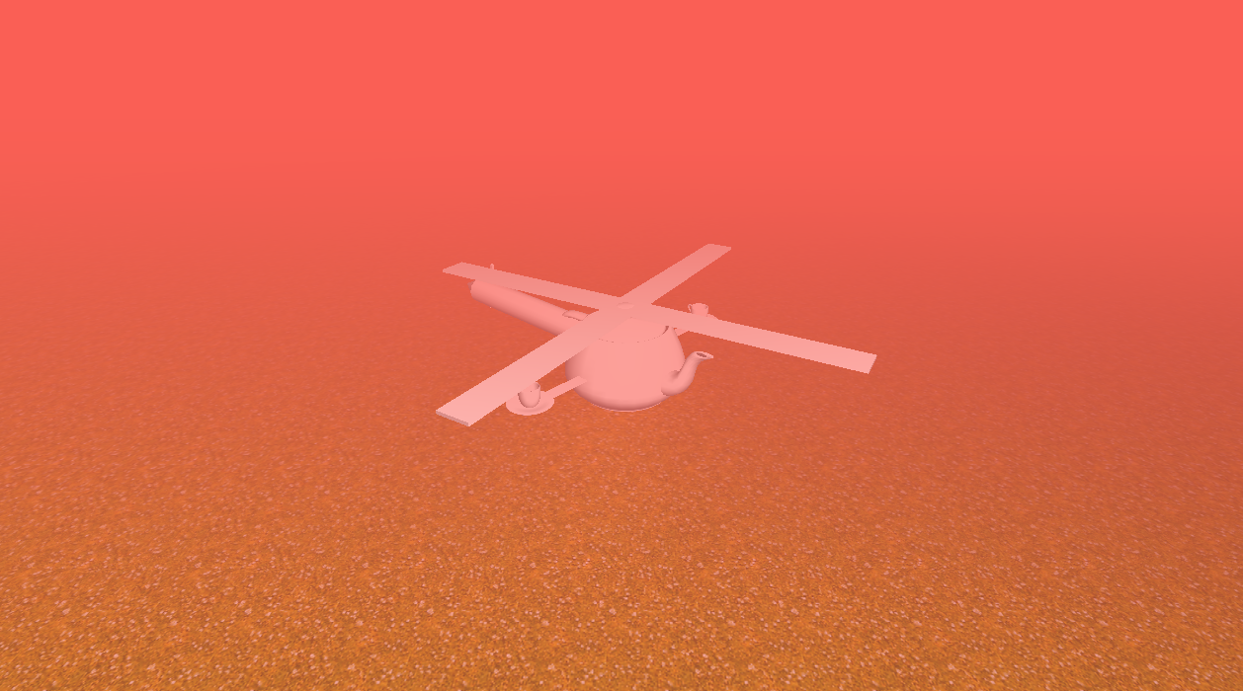

After changing fog mode to EXP2 and messing with the density settings:

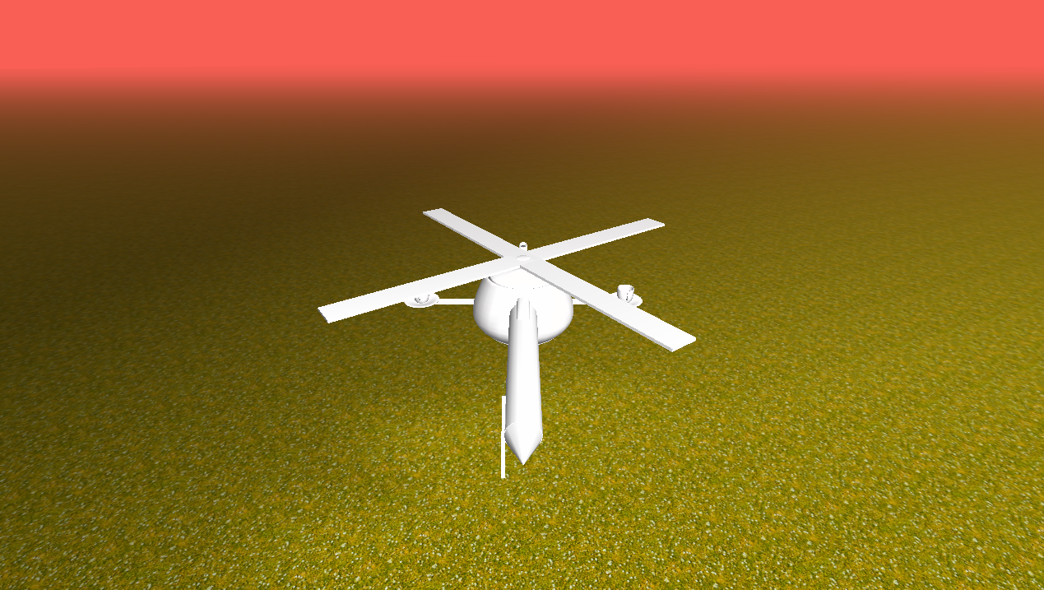

This nicely hides the edges of the map.

# 1st June

Added new textures, and a gigantic Gus Fring billboard. The scene is now populated with rotating trollface cylinders, per the proposal.

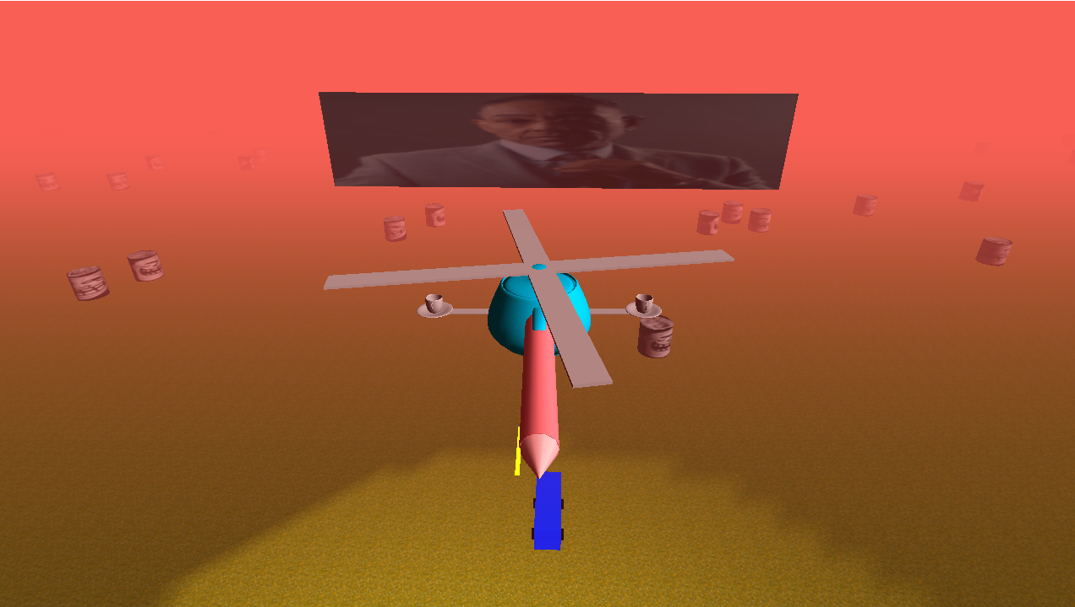

I’ve also added the sun into the scene as a static object, and learned a cool new hack. To make it actually visible I can disable fog before rendering it and then turn it back on later. This stops the fog from affecting the sun. That blue thing is a bus. Trust me.

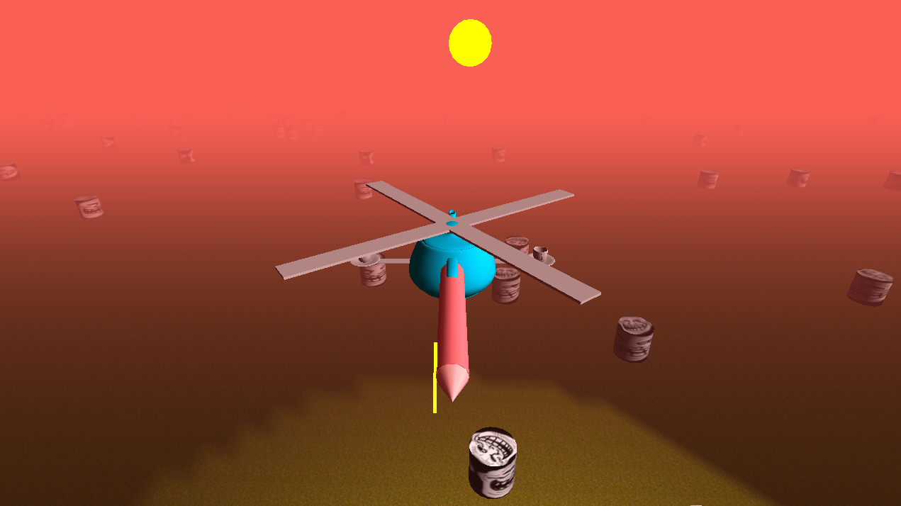

The trollface positions are also randomly generated each time.

While creating the Auckland Transport bus, I found some stray matrix pop calls, which resulted in several undefined behaviours unobservable until I tried to render the bus.

# 4th June

Got road working. Inserted gigantic Gus Fring billboard.

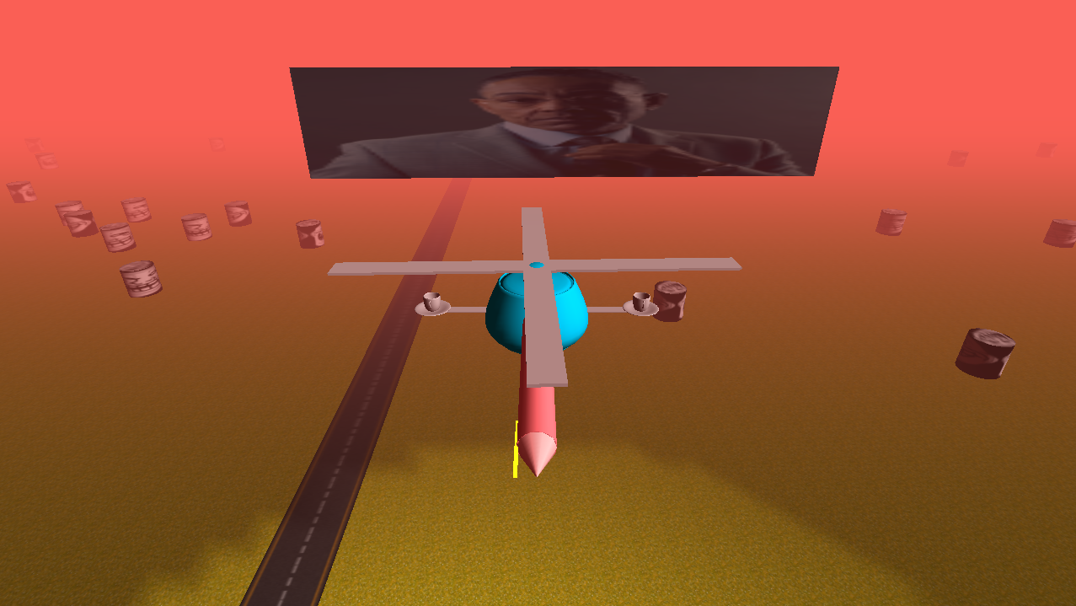

# 6th June

Added enemy helicopter using the same render function as the player’s helicopter. A side effect of reusing the same function is that now all spinning objects move at double speed due to the static nature of the rotor rotation variable. Solution? Have the spin rate.



It should also be noted that Gus Fring is only visible when light from the sun reflects off his portrait.

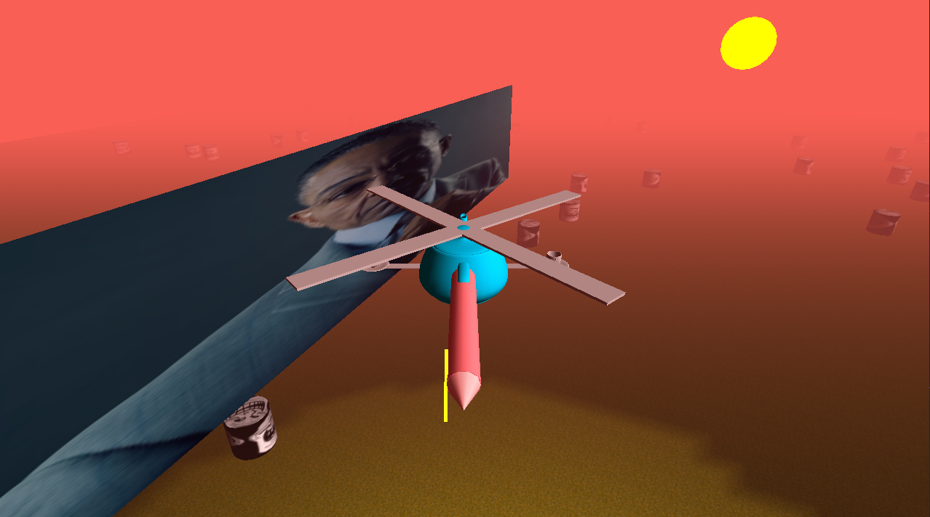

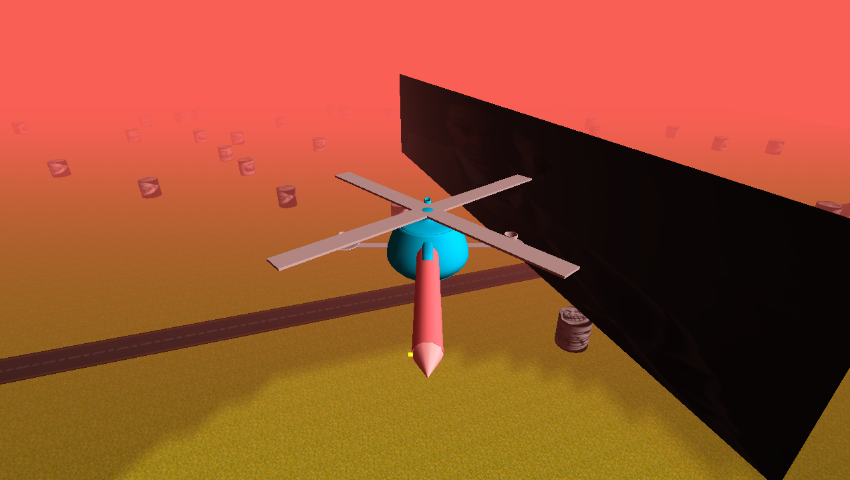

Another side effect of working smarter:  
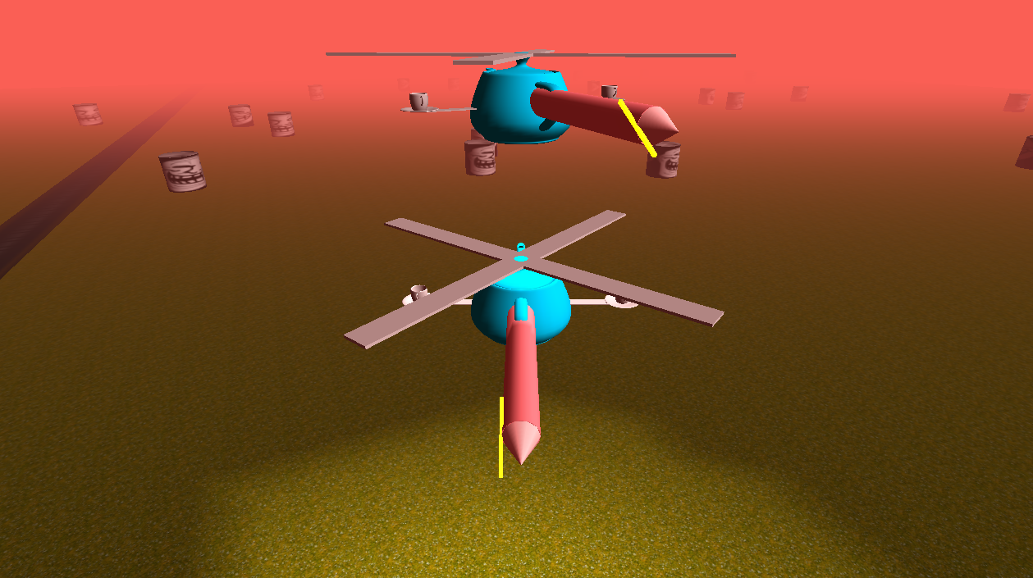

The enemy helicopter also has a light, which is also conveniently toggled by the same key as the player’s helicopter. How neat is that?

After this I added the helicopter’s “””AI””” (update function stuffed with static variables)

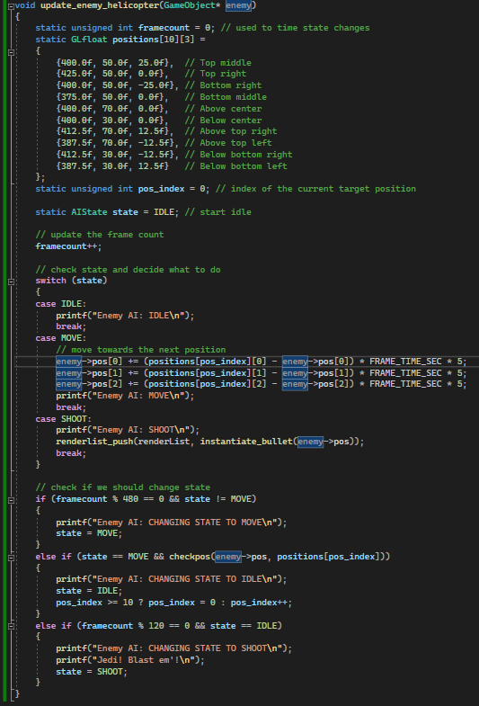

It is also toggleable.

# 7th June

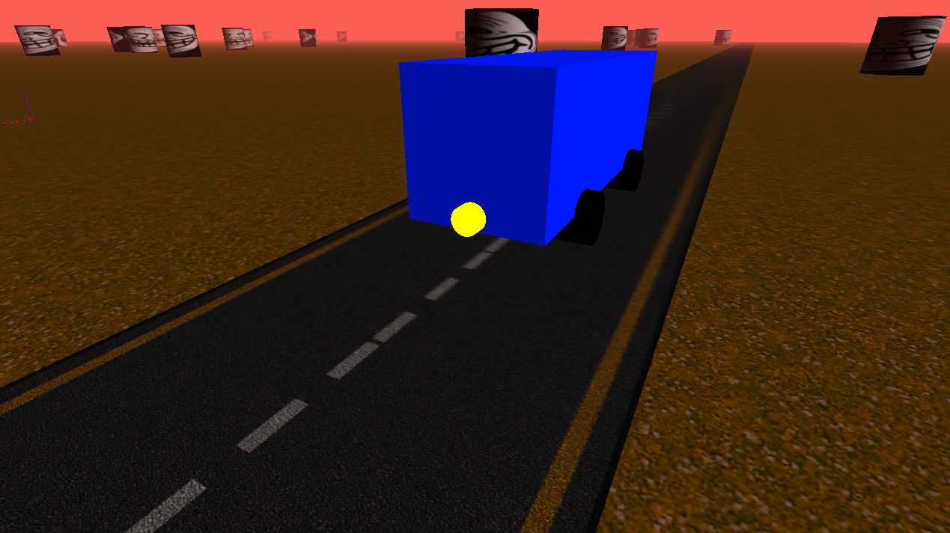

Bus has a light and an actual light. It still looks hideous. This bus is travelling so fast that it ploughs through any trollface cylinder.

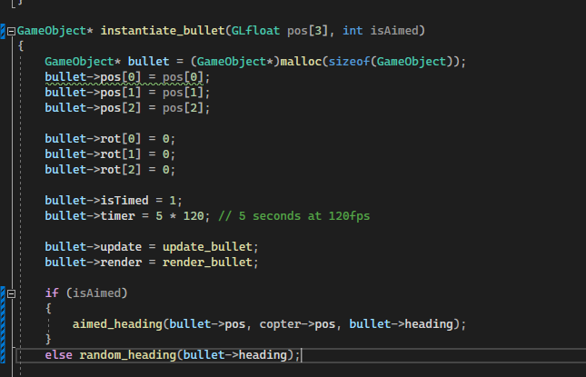Modified bullet code so that aimed attacks are now available. As if collision detection was implemented.

I have gone ahead and implemented a simple pattern from Touhou, based off this code:  
<https://sparen.github.io/ph3tutorials/ph3u1l11a.html>

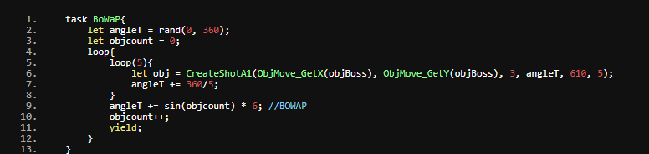

This is the infamous “Border of Wave and Particle” spell card from Touhou 7.

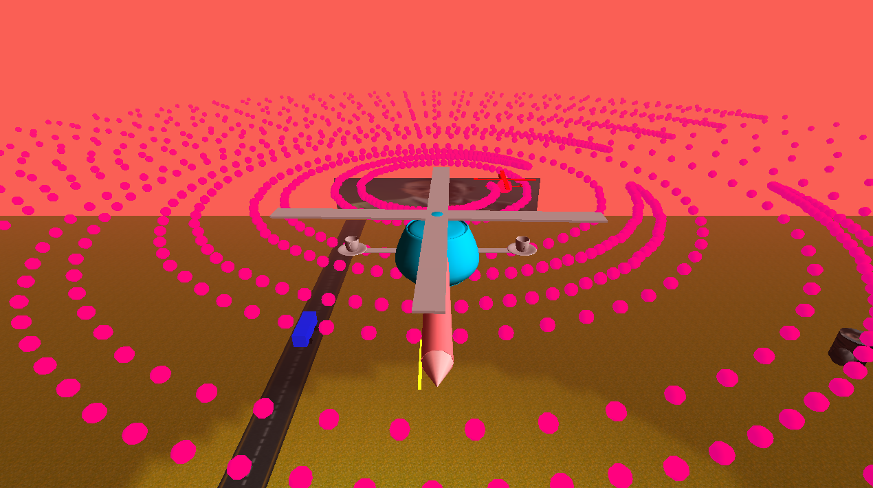

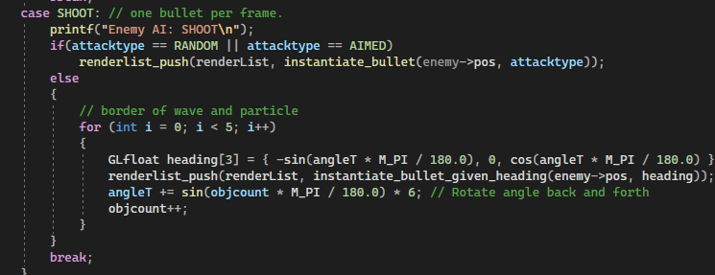

It took a bit of faffing about, but it’s working. I’ve also fixed the release build. Visual studio doesn’t detect when you forget to return a pointer which was causing access violations. 😐

## Performance table

|  |  |  |  |
| --- | --- | --- | --- |
| Name | CPU | GPU | Performance |
| Shayna | Ryzen 7 5800X | RTX3070ti | “I beat it!” (no collision detection) |
| Xiaofeng | Unknown | Unknown | “It runs now do HSS” |
| Simone | Ryzen 5 3300 | RTX3060ti | “Yeah, it runs” |

It turns out that I forgot to make the rotors spin relative to the height of the copter. No worries, I can repurpose the velocity variable in the gameobject object.

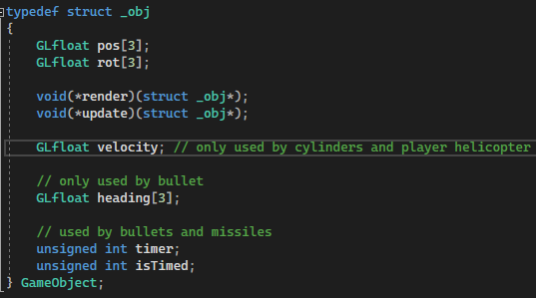

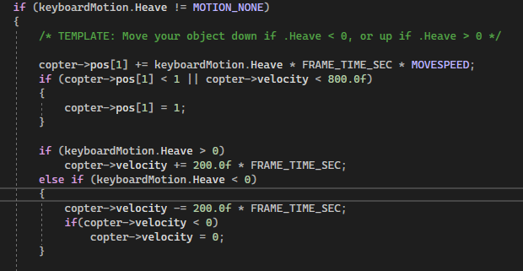

This keeps the helicopter on the ground unless the rotors are spinning fast enough.

# Critical evaluation

Here’s a list of things that didn’t make the final cut:

* Collision detection
* Low-poly trees
* Rough terrain
* Particle system
* Maniac bus route (the bus speeds down the road like the game desert bus)

I have also had to make a few changes since the proposal.  
The camera and player don’t lock on to the enemy, the bullets are closer to magenta than red, and the attack pattern, while still Touhou related, isn’t the same attack. I am still quite pleased with how the enemy helicopter came out though, especially with the scripted behaviour fitting into a single function. I am reasonably happy with the end product, though my attitude shifted from “Oh I should design this system well” at the start to “A magic function in this file fixes it? Thank God”.

The final scene as I would describe it, is a surreal dreamscape with a hodgepodge of assets from the internet and lying around my computer.